PRESENTING CLINICAL SIGNS
History: Recheck echo. Increased cough on exertion, "hack", non-productive, no SOB, appetite + attitude stamina= WNL.
-Current medications: Pimobendan 2.5mgs x 3/4 TID, Lasix 12.5mgs 1 a.m. 1.5 pm, Enalapril 2.5mgs BID, Spironolactone 25mgs x 1/2 BID, Denamarin 1/4-tab SID, Hycodan - PRN.
-Abnormal PE/Chem/CBC/UA Results: (7/2/21): Alk. Phos. 411 (23-212), BUN 51 (7-27), creat. 1.2, CBC: WNL.
-Pertinent previous echo findings (4/2021 EL): Mild LAE, mild PAH, mild LVE.

RADIOGRAPHIC FINDINGS *NOTE: Images submitted for supplemental cardiac information only.
Significant cardiomegaly with LA enlargement. Mainstem bronchi compression is apparent. No obvious evidence of CHF.

ECHOCARDIOGRAM FINDINGS
2D, m-mode and Doppler imaging are available. Diffuse thickening of mitral valve leaflets (anterior> posterior) with mild prolapse into the left atrial lumen. Severe eccentric mitral regurgitation with severe left atrial dilation. Significant LV dilation with hyperdynamic myocardial function. The tricuspid valve appears mildly thickened, with mild tricuspid regurgitation. Mildly elevated velocity. Mild right atrial and ventricular dilation consistent with early pulmonary arterial hypertension. The pulmonic and aortic valves are normal in morphology and mobility. Normal pulmonic and aortic outflow velocities. No pulmonic or aortic insufficiency. No pericardial or pleural effusion noted. No cardiac tumors observed.

CARDIAC CHART
CANINE  CARDIAC  PARAMETERS | MR  VMAX  (m/s) | TR  VMAX  (m/s) | LA/AO  (Boon method) | LA/AO  (Heart Base; Swe) | FS  (%) | EF  (%) | EPSS  (cm)
NORMAL PARAMETER | 4.5-5.5 | <2.7 | 1.3 | <1.6 | 28-40 | 40-100 | <0.6
PATIENT | 5.3 | 3.0 | 2.0 | 2.2 | 33 | 63 | 0.25
CANINE  CARDIAC  PARAMETERS | HR  (BPM) | AV  VMAX  (m/s) | PV  MAX  (m/s) | BODY WEIGHT  (kg) | LA  2D short axis  Base view  (cm) | LVIDd  Avg; 2D and m-mode short axis  (cm) | LVIDs  Avg; 2D and m-mode short axis  (cm)
NORMAL PARAMETER | 50-100 | 0.7-1.7 | 0.7-1.6 | BELOW | BELOW | BELOW | BELOW
PATIENT | 100 | 1.5 | 1.0 | 6.7 | 2.37 | 3.4 | 2.3
*Normal chamber parameters expressed as a mean value (SD) |  |  |  | 3 | 1.27 (5.3) | 2.46 (2.46) | 1.36 (5.5)
BODY WEIGHT DEPENDENT PARAMETERS  *Note: All measurements based upon multi-modal images and methods. An average value is reported.  Adapted from June Boon, Veterinary Echocardiography, 1998  Rishniw M and Hollis NE, J Vet Intern Med 2000; 14:429-435  Hansson et al, Vet Rad and Ultrasound 2002  Bonagura et al. Echocardiography: principles of interpretation, Vet Clin North Am 15:1177, 1995 |  |  |  | 5 | 1.40 (4.5) | 2.74 (5.2) | 1.60 (4.7)  2.06
 |  |  |  | 10 | 1.50 (3.8) | 3.27 (3.5) | 2.06 (3.1)
 |  |  |  | 15 | 1.83 (2.0) | 3.71 (2.4) | 2.43 (2.1)
 |  |  |  | 20 | 2.02 (1.9) | 4.14 (2.2) | 2.80 (2.0)  3
 |  |  |  | 25 | 2.18 (2.4) | 4.48 (2.9) | 3.10 (2.5)
 |  |  |  | 30 | 2.33 (3.3) | 4.83 (3.9) | 3.39 (3.4)  3.69 (
 |  |  |  | 35 | 2.48 (4.3) | 5.17 (5.0) | 3.69 (4.5)
 |  |  |  | 40 | 2.62 (5.2) | 5.48 (6.1) | 3.96 (5.4)
 |  |  |  | 50 | 2.88 (7.1) | 6.07 (8.3) | 4.46 (7.4)

INTERPRETATION OF THE FINDINGS & FURTHER RECOMMENDATIONS
Chronic degenerative valve disease persists with severe mitral and mild tricuspid regurgitation. Significant left atrial enlargement would suggest the disease may have progressed; however, there is certainly some interpreter variability. Regardless, there is risk for spontaneous congestive heart failure and close monitoring is advised. Mild TR is also noted, with evidence of early pulmonary hypertension which is unchanged. No additional issues such as systolic dysfunction are identified.

The described cough appears to be secondary to mainstem bronchi compression given a lack of CHF on the chest radiographs. This type of cough is best addressed using aggressive Hydrocodone followed by weaning to the lowest effective dose. Further Lasix increases should only be made if there is respiratory distress independent of the cough and/or pulmonary edema seen on the radiographs. The patient is already on a high dose of Lasix and further increases will not improve this type of symptom. Close monitoring of breathing rates in the future will be paramount to determine the origin of any future cough and help differentiate mechanical from CHF origins. The average survival of canine patients with active pulmonary edema is 8-9 months on medications, however they generally are able to maintain a good quality of life for that period. Patient will always be at risk for recurrent CHF, development of arrhythmias/LA tear, syncope and/or sudden death in the future. Monitoring of renal values is recommended lifelong.

Omega fatty acid supplementation and mild salt restriction may also be of some long-term benefit. Monitor for development of a worsening cough, labored breathing, exercise intolerance or collapse episodes.

PLAN
Screening BP is recommended every 6 months. Continue Pimobendan, Lasix, Enalapril and Spironolactone as prescribed. Highly recommend more aggressive hydrocodone, administer 0.2-0.4mg/kg PO up to q4-6 hfor 3-5 days, if symptom improves wean to lowest effective frequency.

A renal panel and BP are recommended every 3-4 months lifelong.

A recheck echocardiogram is recommended in 6 months to screen for progression, sooner if clinical signs arise/persist.

IMAGES
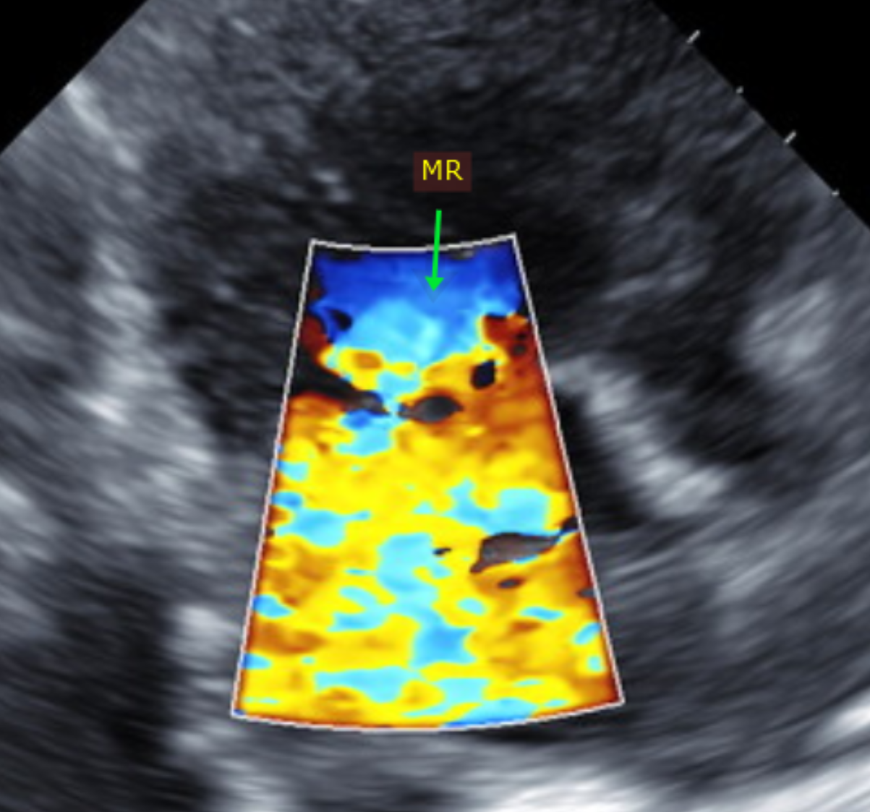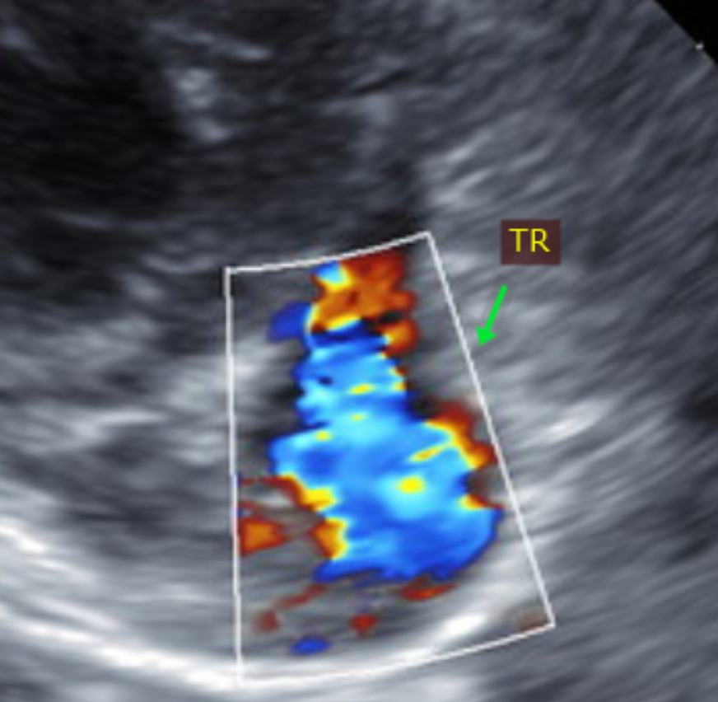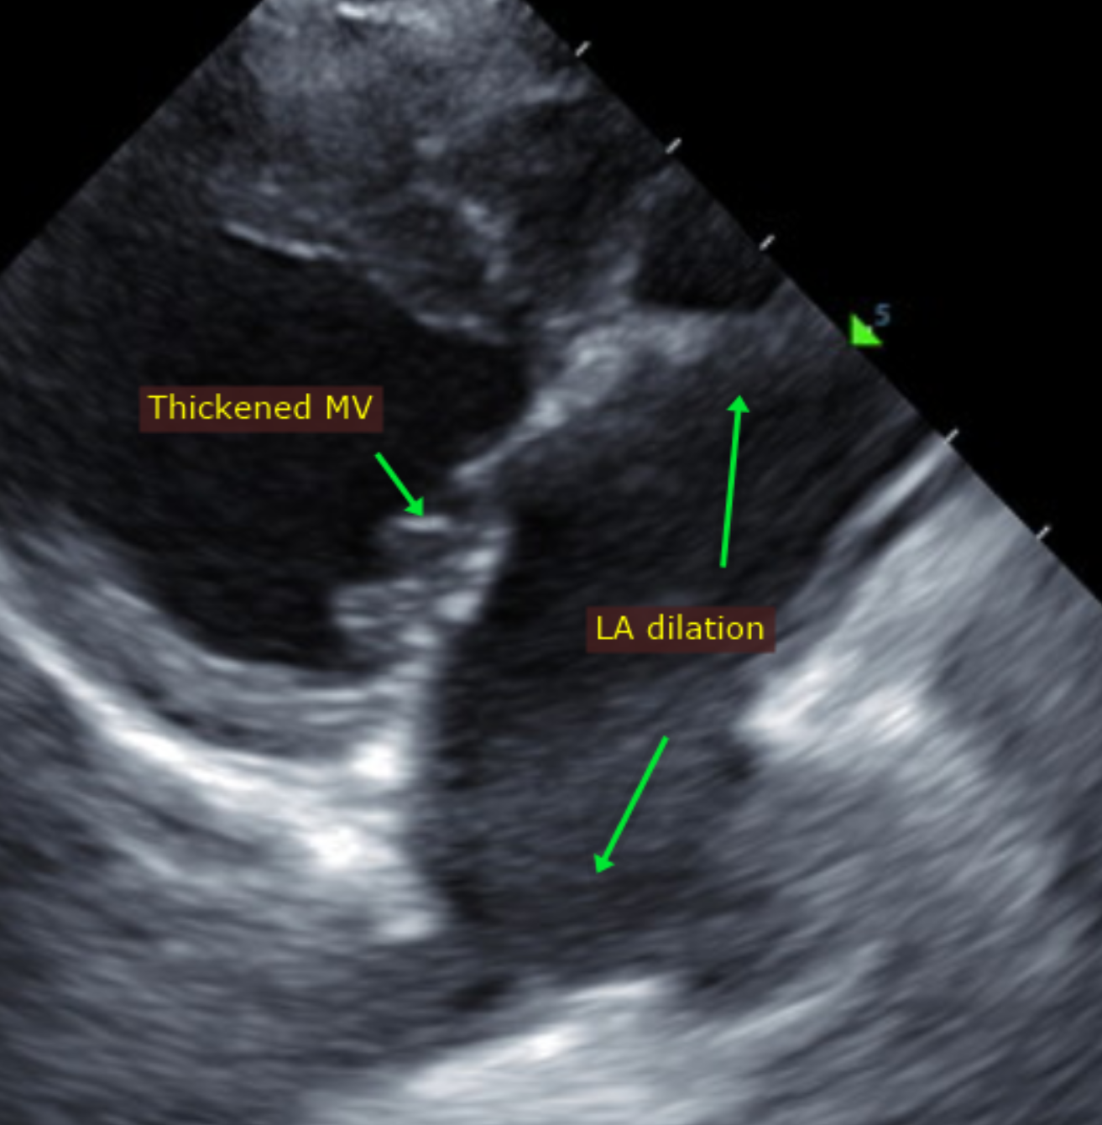

The information and recommendations provided are based on the images presented by the referring veterinarian. No evaluation can be communicated regarding pathology that was not visible in the image/video clips provided.

Thank you for this referral. This report was generated using transcription software, and minor dictation errors may be present. If the clinical or image interpretation does not parallel your findings or if I can be of any further assistance, please contact me.

Maggie Machen Lamy, DVM
Diplomate of the American College of Veterinary Internal Medicine (Cardiology)
info@sonopath.com

